Project Fan Page Taylor Swift

27/07/2021

Ritik

2021

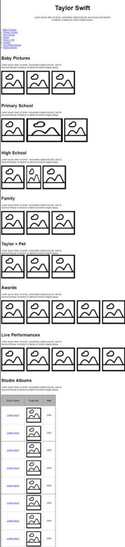**Requirements:**

Gantt Chart – to keep track of progress while working on the project

Proof of work – To confirm that the project is my own work and has not been copied

Project Plan – The process of creating the project

The website will need to have 8 sections that are listed below:

* Title
* Short Description
* Table of contents
* Baby pictures
* Primary School
* High School
* Family Pictures
* Taylor + Pets
* Awards
* Live Performances
* Studio Albums

**Design:**

For the design I have used the wireframe that was given to do the design of the website.

The Title of the website will be aligned to the centre, as well as the description

Need to create an index which gives the user the ability to be able to click and open any of the sections

Sections 1 – 7 will have a title with a description and 3 images to go with it, as seen on the wireframe.

Section 8-9 will also be the same as 1-7 but will have 5 images instead of 3

Section 10 will have a table with 8 rows for each of the different studio albums. Each row will have a title, image and year.

The Background colour of the website will be paleturquoise

**Implementation**:

* First of all, I started by creating the html file

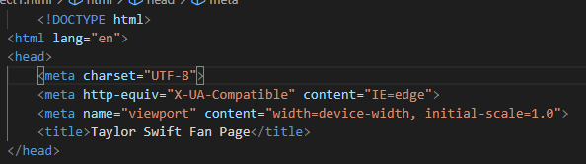

* Researched and gathered the images for the project,

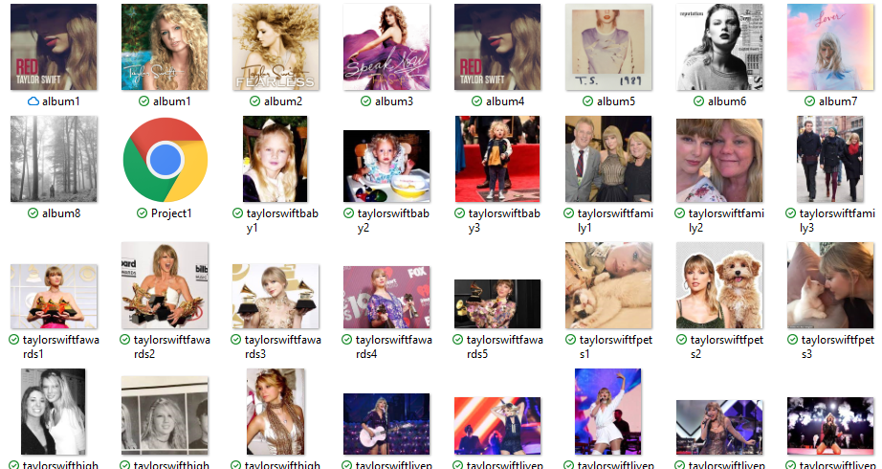

* Created Title and description

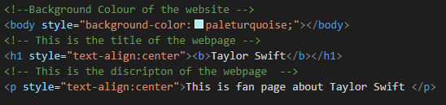

* 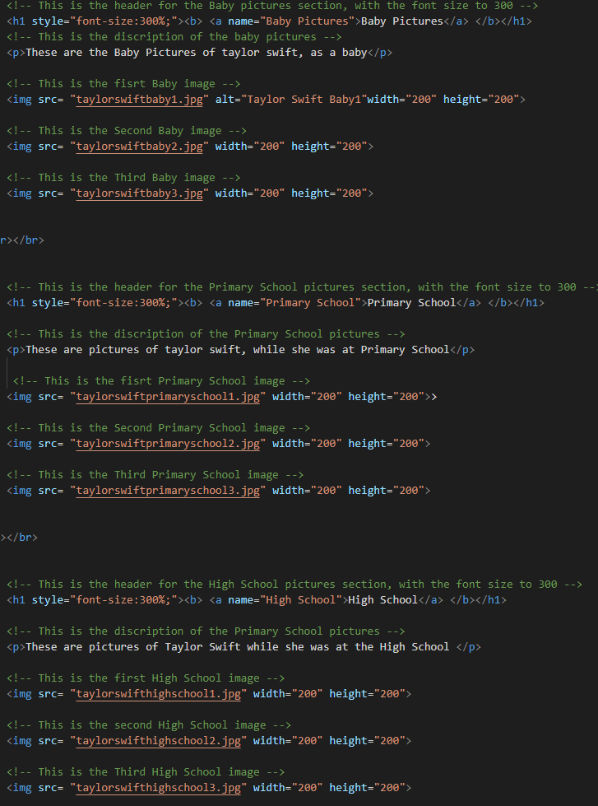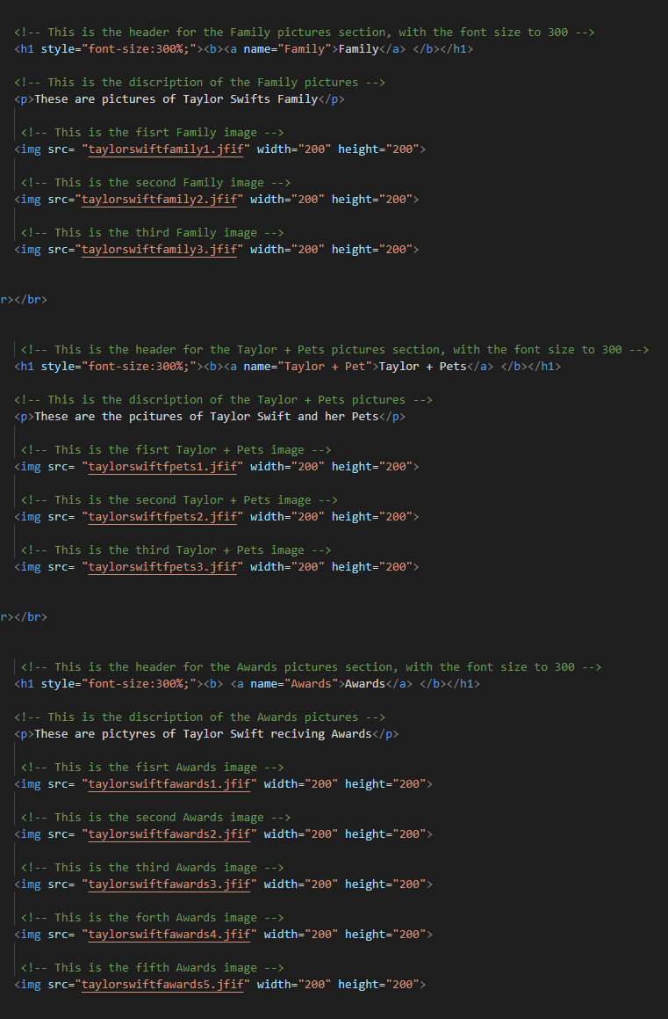Created 7 sections with the images and the descriptions.
* Added the index with links to go to each section locally

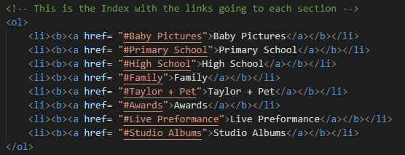

* Created the table and added the images and description

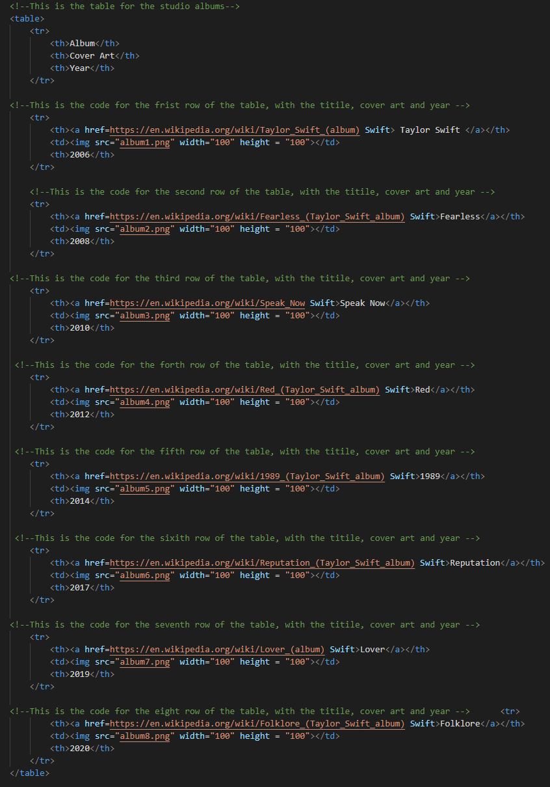

**Verification**

After creating the website, I have gone ahead and tested to confirm that the website is fit for purpose.

I have done this by:

* Testing the internal links from to index that scrolls to each section

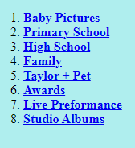

* Tested to confirm that the external links in the table are working, by confirming that they are opening up into an external page.

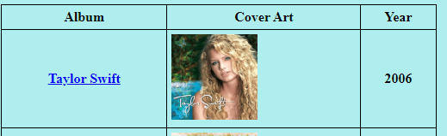

* Confirmed that the all the images, descriptions and titles are all same size

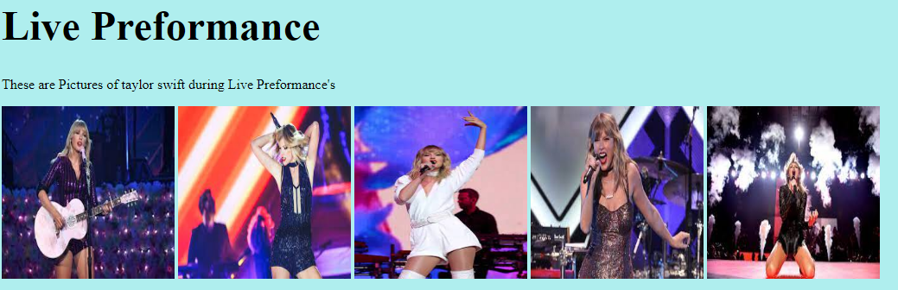

After finishing the testing and verification, I can confirm that website is ready to be deployed in the customer environment.

**Maintenance**

For future maintenance of the website I have added comments for each line of code in the different section to describe what it does.

This is so that when in the future, if the website is needing to be updated, each line will have a short description to let the user know what It means.

(Refer to image as an example)

